
Office Hours with


Date: Wednesday, February 17th
Location: Economics Career Center North Hall, 2nd Floor
Time: 11:00am – 2:00pm
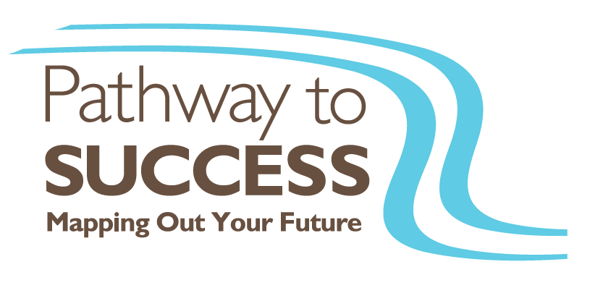
Come visit BDO to learn more about their summer leadership program, Pathway to Success!

