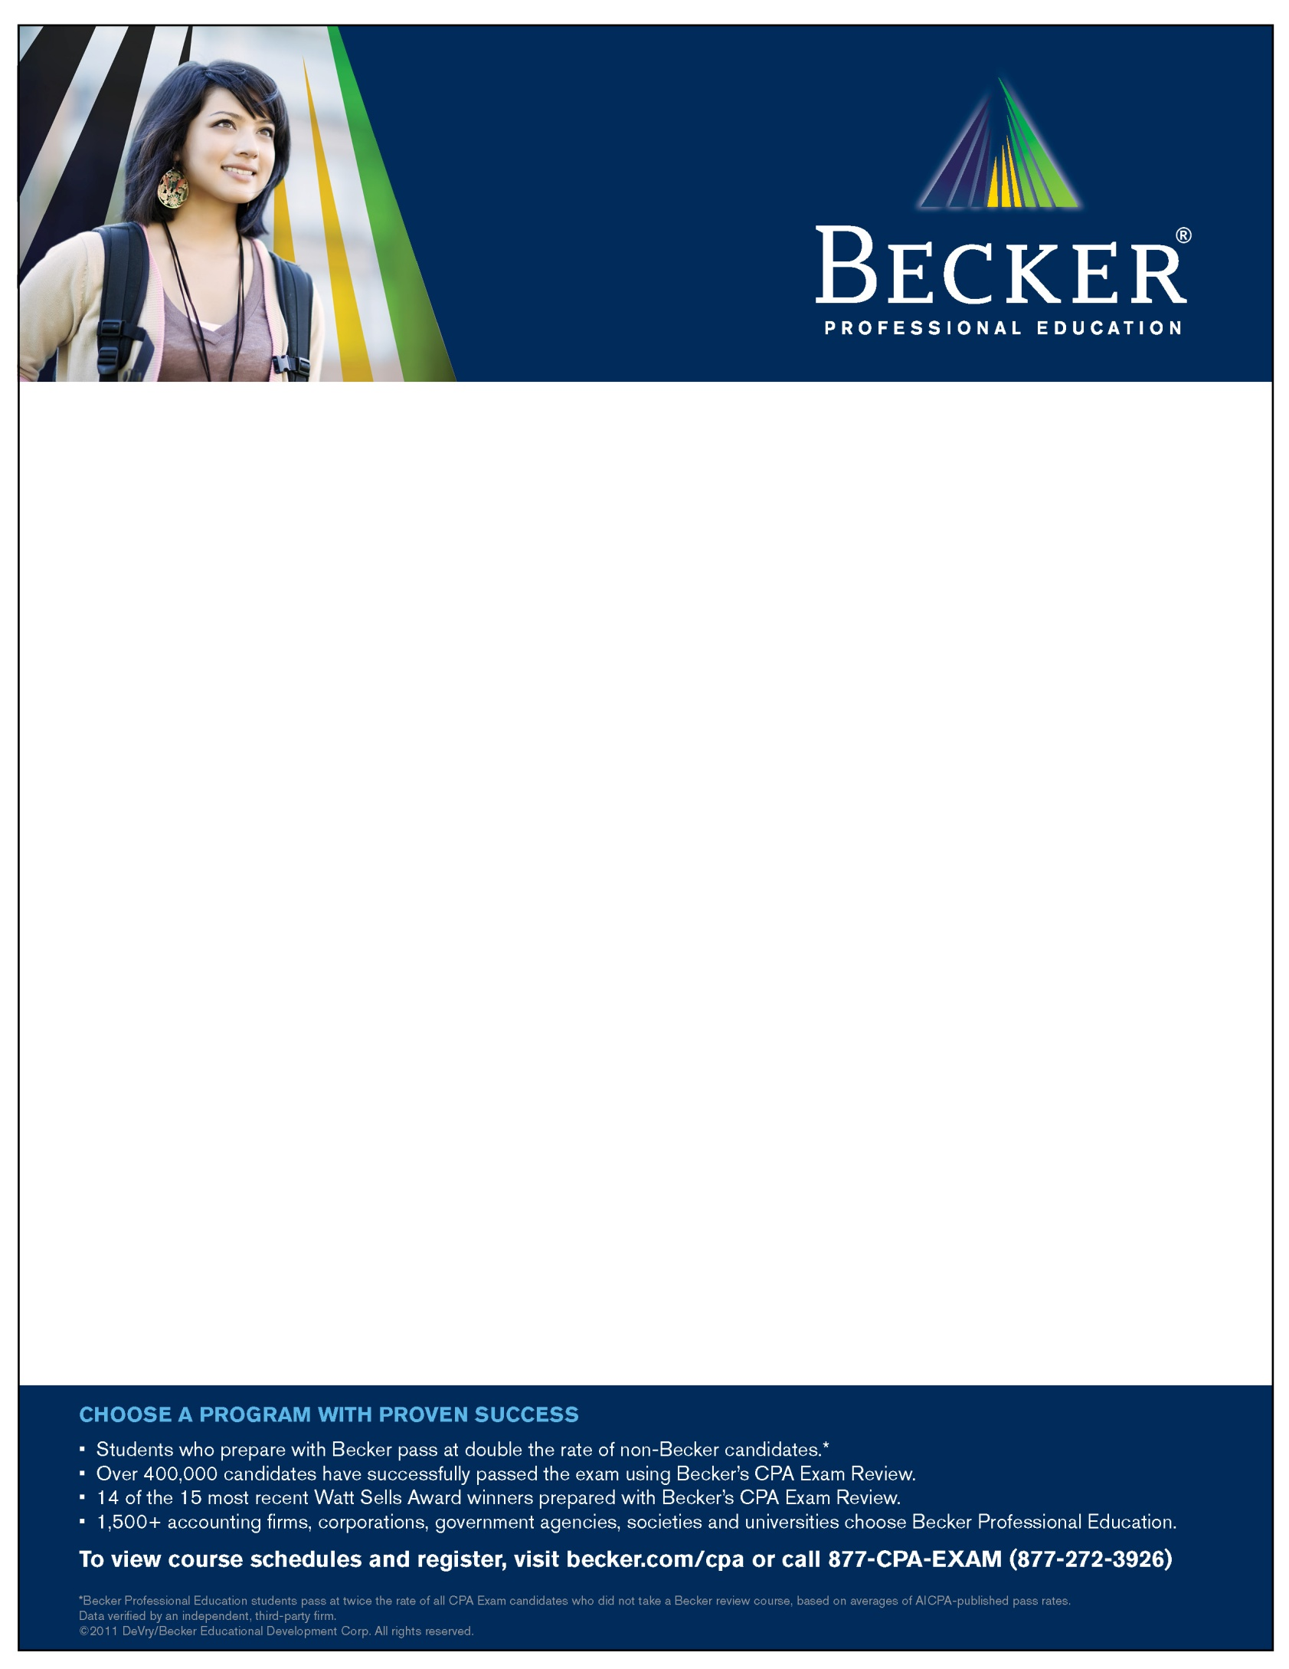

Complimentary
CPA Exam Information Session and 2011 Product Demonstration

Wednesday, May 4th, 2011 – 2:00 p.m. – 3:30 p.m.
University of California Santa Barbara
North Hall – Room 1110

During this workshop, you will:
- Learn how you can study and pass ALL 4 parts of the CPA exam in 6-9 months (or less)

- Get insight on the changes to the CPA Exam, licensure requirements and how to navigate the CPA Exam application process

- Gain valuable information on the exam format, multiple choice questions, new task-based simulations and the testing environment

To RSVP or for more information, please contact Scott Barbret
At: sbarbret@becker.com

Pizza and soft drinks will be provided beginning at 1:45 p.m.

Type your event information here

